­

**2022**

Computer

Networks

B. Sc. Electronics, 2nd Year

21HEL2166

Harsh Vardhan

Roll No. : _________________

Course : ________________________

Student’s Name : __________________

PractiCal file

**Q1. Create ­HTML document with following formatting – Bold, italics, underline, color, heading, title, font and font width, background, paragraph, line break, horizontal line, blinking text as well as marquee text.**

**>>>**

<!DOCTYPE html>

<head>

  <title>First HTML Page</title>

</head>

<body>

  <h2 style="color: rgb(0, 0, 255);">This sentence is in Blue color</h2>

  <h1>This is h1 heading</h1>

  <h2>This is h2 heading</h2>

  <h3>This is h3 heading</h3>

  <h4>This is h4 heading</h4>

  <h5>This is h5 heading</h5>

  <h6>This is h6 heading</h6>

  <b>This is Bold type</b>

  <i>This is Italic type</i>

  <u>This is Underlined sentence type</u>

  <p>This is a paragraphThis is a paragraph</p>

  <Br> *<!--this is a line break-->*

  <hr> *<!--this is a horizontal line-->*

  <marquee direction="left">This is a marquee text</marquee>

</body>

</html>

**Output>>>**

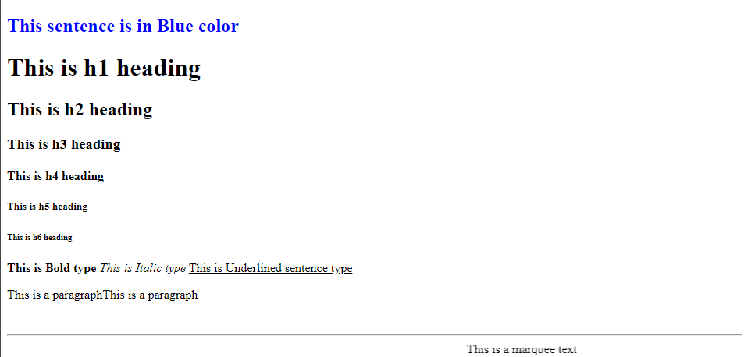

**Q2. Create HTML document with ordered list and unordered list, Inserting images, internal and external linking.**

**>>>**

<!DOCTYPE html>

<head>

  <title>List in HTML</title>

</head>

<body>

  <a name="Link_1">Hello how are you? this is just a basic structure of list

</a><br>

  <a name="Link_2">This world is amazing, be proud to live here !!</a>

  <h2>-Ordered List-</h2>

  <ol type="1">

    <li>Science</li>

    <li>Commerce</li>

    <li>Humanities</li>

  </ol>

  <h2>-Unordered List-</h2>

  <ul>

    <li>Electronics</li>

    <li>Computer</li>

    <li>Mathematics</li>

  </ul>

  <h2>-Image Inserting-</h2>

  <img src="https://encrypted-tbn0.gstatic.com/images?q=tbn:ANd9GcTDstxpX8FgO24-O3LSqLzvfOiwHV_ubon9sQ&usqp=CAU"

    alt="This is a Image" width="150px">

  <h2>-Internal Linking-</h2>

  <a href="#Link_1">Link_1</a><br>

  <a href="#Link_2">Link_2</a><br>

  <h2>-External Linking-</h2>

  <a href="https://www.google.com">Google</a><br>

  <a href="https://www.youtube.com">Youtube</a><br>

  <a href="https://www.github.com">Github</a><br>

</body>

</html>

**Output>>>**

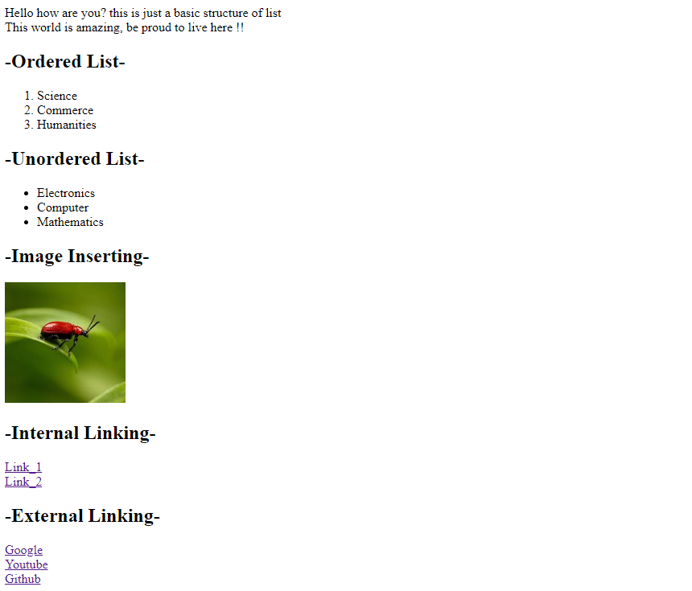

**Q3. Create HTML document with table.**

**>>>**

<!DOCTYPE html>

<head>

  <title>Tables in HTML</title>

</head>

<body>

  <table border="1">

    <tr>

      <th width="50px">Box no. 1</th>

      <th width="100px">Box no. 2</th>

      <th width="100px">Box no. 2</th>

      <th width="100px">Box no. 3</th>

      <th width="50px">Box no. 4</th>

    </tr>

    <tr>

      <td height="30px" colspan="3">Row no. 1</td>

      <td rowspan="2" colspan="2"><img src="images/Artboard 1.png" alt=""

width="50px"></td>

    </tr>

    <tr>

      <td height="30px" colspan="3">Row no. 2</td>

    </tr>

  </table>

</body>

</html>

**Output>>>**

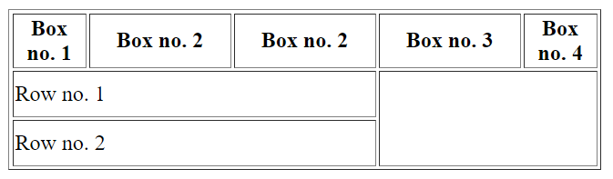

**Q4. Create Form with Input Type, Select and Text Area in HTML.**

**>>>**

<!DOCTYPE html>

<head>

  <title>Document</title>

</head>

<body>

  <form action="">

    Name: <input type="text" placeholder="Harsh Vardhan"><br><br>

    E-mail: <input type="email" placeholder="abc@gmail.com"><br><br>

    Course: <select name="course" id="course">

      <option value="none">--Select Your Course--</option>

      <option value="Electronics">Electronics</option>

      <option value="Chemistry">Chemistry</option>

      <option value="Physics">Physics</option>

      <option value="Maths">Maths</option>

    </select><br><br>

    Address: <textarea name="" id="" cols="40" rows="3"></textarea>

  </form>

</body>

**Output>>>**

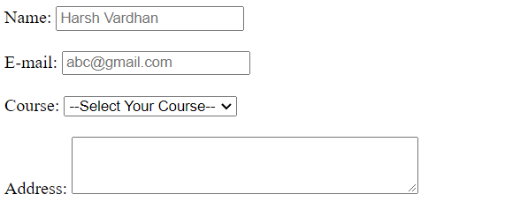

**Q5. Create HTML document containing Roll no., student’s name, and grade in a tabular form.**

**>>>**

<!DOCTYPE html>

<head>

  <title>Student's Information</title>

</head>

<body>

  <table border="1">

    <tr>

      <th width="50px">Roll no.</th>

      <th width="100px">Student's Name</th>

      <th width="50px">Grade</th>

    </tr>

    <tr height="30px">

      <td>1</td>

      <td>Harsh Vardhan</td>

      <td>A+</td>

    </tr>

    <tr height="30px">

      <td>2</td>

      <td>Arvind Kumar</td>

      <td>B+</td>

    </tr>

    <tr height="30px">

      <td>3</td>

      <td>Abhay Kumar</td>

      <td>B+</td>

    </tr>

    <tr height="30px">

      <td>4</td>

      <td>Nayan</td>

      <td>A+</td>

    </tr>

  </table>

</body>

</html

**Output>>>**

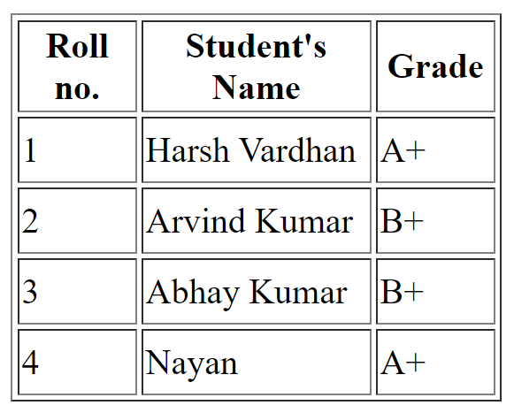

**Q6. Create HTML document(having two frame) which will appear as follows:**

|  |  |
| --- | --- |
| About  Department 1  Department 2  Department 3 | This frame would show the content according to the link clicked by user on the left frame. |

**>>>**

<!DOCTYPE html>

<html lang="en">

<head>

    <title>Mulltiple framed in one webpage</title>

</head>

<frameset cols="*,*">

    <frame name="menu" src="q6menu.html">

    <frame name="side" src="q6out.html">

</frameset>

<body>

</body>

</html>

<!DOCTYPE html>

<head>

  <title>Document</title>

  <base target="text">

</head>

<body>

  <h1>About</h1>

  <ul>

    <li><a href="q1.html">Link 1</a></li>

    <li><a href="q2.html">Link 2</a></li>

    <li><a href="q3.html">Link 3</a></li>

  </ul>

</body>

</html>

**Output>>>**

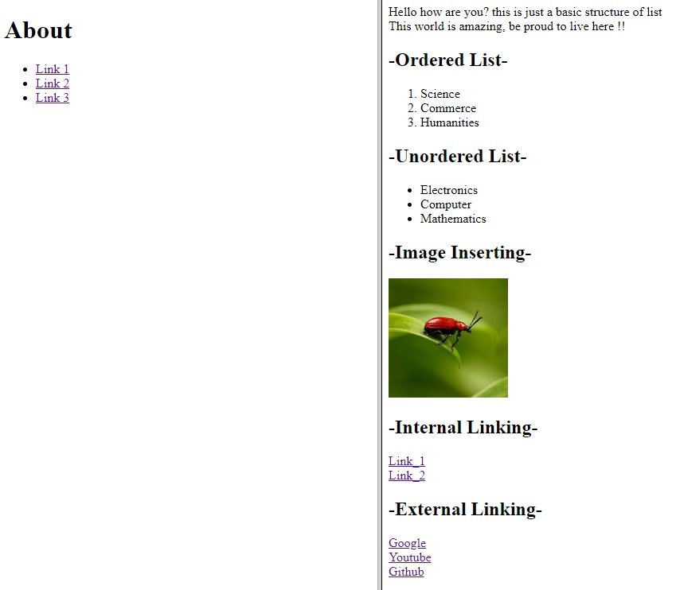

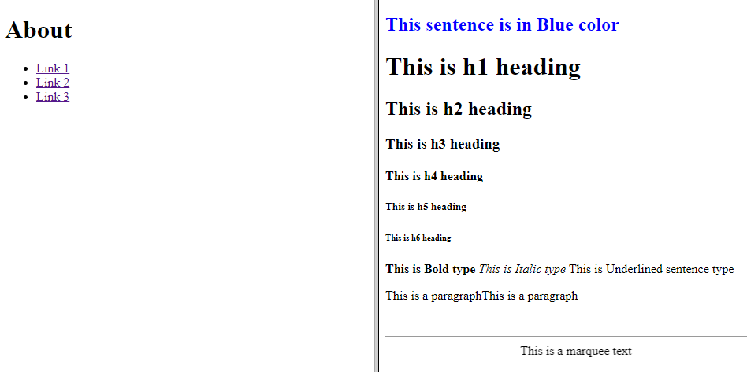

**Q7. Create a HTML document containing horizontal frames as follows:**

|  |
| --- |
| Department names |
| Content according to the link clicked |

**>>>**

<!DOCTYPE html>

<head>

  <title>Mulltiple framed in one webpage</title>

</head>

<frameset rows="*,*">

  <frame name="menu" src="q6menu.html">

    <frame name="text" src="q6out.html">

</frameset>

<body>

</body>

</html>

<!DOCTYPE html>

<head>

  <title>Document</title>

  <base target="text">

</head>

<body>

  <h1>About</h1>

  <ul>

    <li><a href="q1.html">Link 1</a></li>

    <li><a href="q2.html">Link 2</a></li>

    <li><a href="q3.html">Link 3</a></li>

  </ul>

</body>

</html>

**Output>>>**

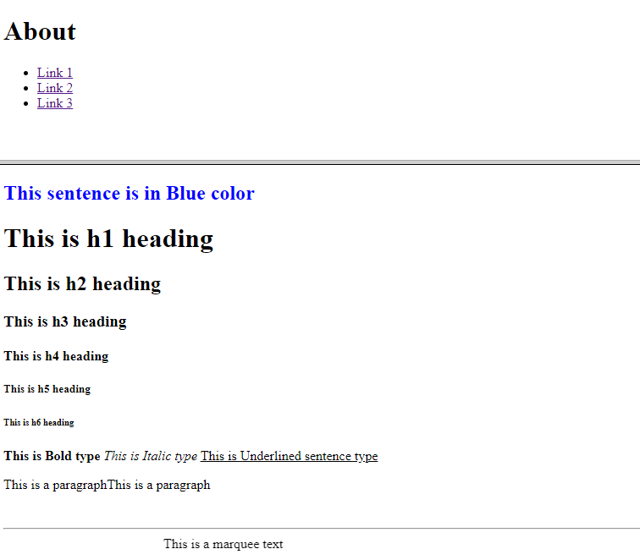

**Q8. Create a website of 6-7 pages with different effects as mentioned in above.**

**>>>**

<!DOCTYPE html>

<head>

  <title>DDUC - Review</title>

  <style>

    * {

      margin: 0;

      padding: 0%;

      box-sizing: border-box;

    }

    body {

      font-family: sans-serif;

    }

    .row {

      display: flex;

      width: 100%;

      margin: auto;

      overflow-x: hidden;

      margin-top: 20px;

    }

    .col {

      width: 100%;

      margin-left: 60px;

    }

    .col img {

      border-radius: 10px;

    }

    body {

      background-color: rgb(224, 227, 230);

    }

    a {

      text-decoration: none;

      color: #fff;

      font-size: 30px;

    }

    .admission {

      border-radius: 10px;

    }

    .admis,

    h1 {

      text-align: center;

      margin-top: 80px;

      font-size: 2.2rem;

      color: #fff;

    }

    .admis h1 {

      color: #000;

    }

    button {

      padding: 10px;

      width: 90px;

      border-radius: 10px;

      cursor: pointer;

      transition: 0.9s;

    }

    button:hover {

      background-color: rgb(0, 255, 255);

    }

    .admission {

      width: 90%;

      height: 300px;

      background-image: linear-gradient(rgba(0, 0, 0, 0.8), rgba(0, 0, 0,

0.8)), url(images/banner2.jpg);

      background-size: cover;

      margin: auto;

      margin-top: 40px;

    }

    .centre {

      padding-top: 70px;

    }

    footer {

      width: 100%;

      height: 30px;

      background-color: #000;

      color: #fff;

      text-align: center;

      margin-top: 30px;

    }

  </style>

</head>

<body>

  <div style="text-align: center; background-color: rgb(34, 34, 81) ;">

    <img

src="https://upload.wikimedia.org/wikipedia/en/6/66/Deen_Dayal_Upadhyay

a_College%27s_official_logo.jpg" alt="" width="150px"><br>

    <a target="_blank" href="https://dducollegedu.ac.in" style="color:

rgb(255, 255, 255);"><b>Deen Dayal Upadhaya College</b></a><br><br>

  </div>

  <section

    style="background-image: linear-

gradient(rgba(0,0,0,0.6),rgba(0,0,0,0.6)),url(images/banner.png)

;background-size: cover; color: #fff; padding-left: 30px; margin-

bottom: 50px;">

    <br><br><br>

    <h2 style="text-align: center; font-size: 35px;text-transform:

uppercase;"><u>Courses We Offer</u></h2><br>

    <ol>

      <li><u><b>UNDERGRADUATE COURSES</b></u>

        <ul style="list-style-type:disc;">

          <br>

          <li><i>BA(Hons)English</i></li>

          <li><i>Bsc(Hons)Botany</i></li>

          <li><i>Bsc(Hons)Electronics</i></li>

          <li><i>Bsc Physical science</i></li>

          <li><i>Bsc(Hons)Mathematics</i></li>

          <li><i>Bsc(Hons)Physics</i></li>

          <li><i>Bsc(Hons)Chemistry</i></li>

          <li><i>Bsc(Hons)Zoology</i></li>

        </ul>

      </li>

      <br>

      <li><u><b>OTHER COURSES</b></u>

        <ul style="list-style-type:disc;">

          <br>

          <b>Certificate Course:</b><br><br>

          <li><i>Certificate in Russuian language</i></li>

          <li><i>Certificate in Frence language</i></li>

          <li><i>Certificate in German language</i></li>

          <br>

          <b>Add-on Courses:</b>

          <br><br>

          <li><i>ECPDT</i></li>

          <li><i>Online Retailing</i></li>

        </ul>

      </li>

      <br><br>

    </ol>

    <hr>

  </section>

  <section>

    <h2 style="text-align: center; font-size: 35px;text-transform:

uppercase;"><u>Infrastructure</u></h2>

    <div class="row">

      <div class="col">

        <img src=<https://dducollegedu.ac.in/Datafiles/cms/Library/L1.jpg>

width="300px alt="library">

        <h3><b>Huge library</b></h3>

        <p>Lorem ipsum dolor sit amet <br> consectetur adipisicing elit. <br>

          Commodi!</p>

        <button>See more</button>

      </div>

      <div class="col">

        <img src="https://www.dducollegedu.ac.in/Datafiles/cms/cafe.jpg" width="300px" alt="library">

        <h3><b>Tasty Food</b></h3>

        <p>Lorem ipsum dolor sit amet <br> consectetur adipisicing elit. <br>

Commodi!</p>

        <button>See more</button>

      </div>

      <div class="col">

        <img src="https://www.dducollegedu.ac.in/Datafiles/cms/indoo%20court.jpg" width="300px" alt="library">

        <h3><b>Sport courts</b></h3>

        <p>Lorem ipsum dolor sit amet <br> consectetur adipisicing elit. <br>

Commodi!</p>

        <button>See more</button>

      </div>

    </div>

  </section>

  <section class="admis">

    <h1><u>Admission Portal</u></h1>

    <div class="admission">

      <div class="centre">

        <h2>Admission Portal for <br>UnderGraduate Courses</h2>

        <button>Enroll</button>

      </div>

    </div>

  </section>

  <footer>

    All right reserved &copy <a href="https://dducollege.ac.in" style="font-

size:20px;">dducollege.ac.in</a>

  </footer>

</body>

</html>

**Output>>>**

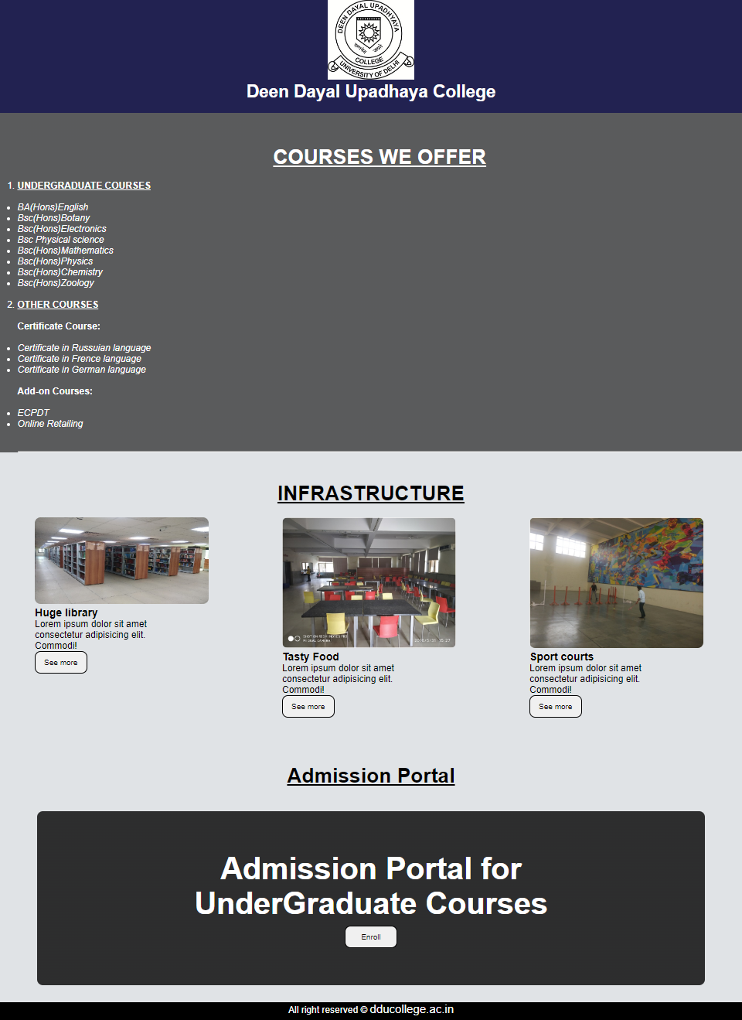

**Q9. Create HTML document (having multiple frame) In the following three formats:**

|  |
| --- |
| Frame 1 |

|  |  |
| --- | --- |
| Frame 2 | Frame 2 |

**>>>**

<!DOCTYPE html>

<head>

  <title>3 Frames</title>

</head>

<frameset rows="70%,*">

  <frame src="q2.html">

    <frameset cols="50%,*">

      <frame src="q3.html">

        <frame src="q5.html">

    </frameset>

</frameset>

<body>

</body>

</html>

**Output>>>**

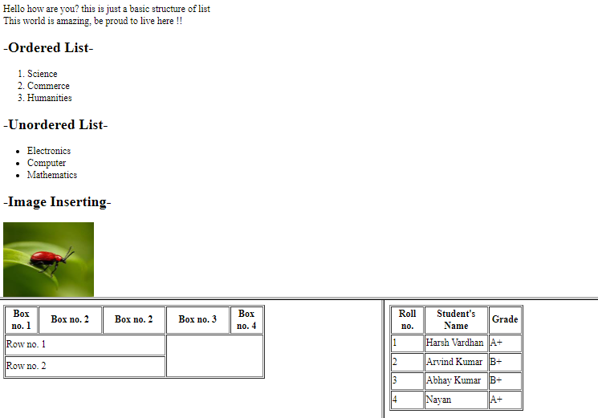

**Q10. Create a form using HTML which has the following types of controls:**

1. **Text Box**
2. **Option/Radio button**
3. **Check Boxes**
4. **Reset and Submit buttons**

**>>>**

<!DOCTYPE html>

<head>

  <title>Form</title>

</head>

<body>

  <div class="container" style="border: 3px solid #000;

    padding: 30px;

    margin: 30px;">

    <h1 class="head">Subscribe to XYZ News Magazine and Emails</h1>

    <p>Intreseted in receiving daily small update of all latest News? Well,

now you can. And best of all,it is free! just fill out this form and

submit it by clicking the "send it in" button. We will put youon our

making list and you will put you on our making list and you will

recieve your fisrt email in 3-5 days

    </p>

    <hr>

    <br>

    <p><b>Please fill the following boxes to help us send the emails and our

news letter</b></p>

    <p><strong>* denotes the required field</strong></p>

    <form action="">

      <label for="Fname">First Name* :</label>

      <input type="text" placeholder="Fisrt Name" required><br><br>

      <label for="Lname">Last Name :</label>

      <input type="text" placeholder="Last Name"><br><br>

      <label for="Business :">Business* :</label>

      <input type="text" placeholder="what's your business" required>

      <p>We must have a correct e-mail address to send you the news

letter</p>

      <label for="email">Email* :</label>

      <input type="email" placeholder="Your Email" required>

      <p>How did you hear about XYZ News Magzine and Email</p>

      <input type="radio" id="web">

      <label for="web">Here on web</label>

      <input type="radio" id="magzine">

      <label for="magz">In a magzine</label>

      <input type="radio" id="tv">

      <label for="tv">Television</label>

      <input type="radio" id="other">

      <label for="other">Other</label><br><br>

      <p>Would you like to be on our regular mailing list</p>

      <input type="checkbox">Yes, we love junk emails <br>

      <hr>

      <button>Reset</button>

      <button>Send it in!</button>

    </form>

  </div>

</body>

</html>

**Output>>>**

